**Aggregate Functions:-**

1) Count the total no. of orders.

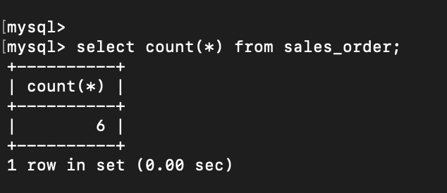

2) Calculate the average price of all the products.

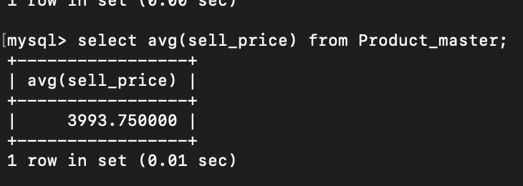

3) Calculate the minimum price of product

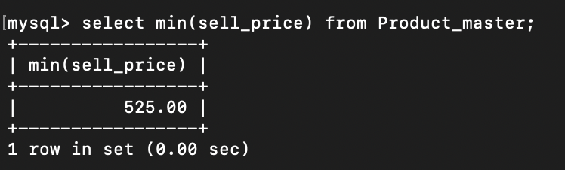

4) Determine the maximum and minimum product price. Rename the title as max_price and min_price respectively.

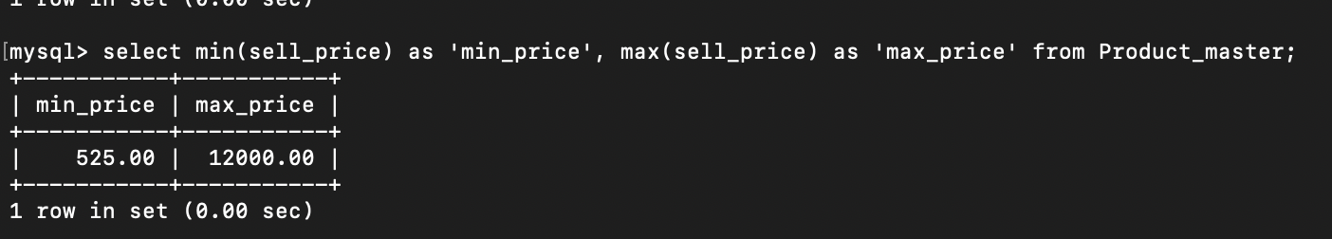

5) Count the number of product having price greater than or equal to 1500.

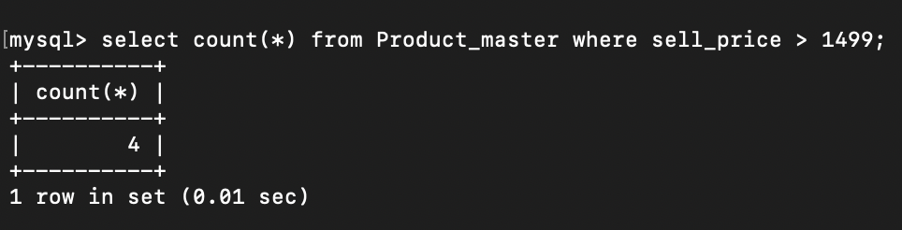

6) Find all products whose qty_on_hand is less than reorder level.

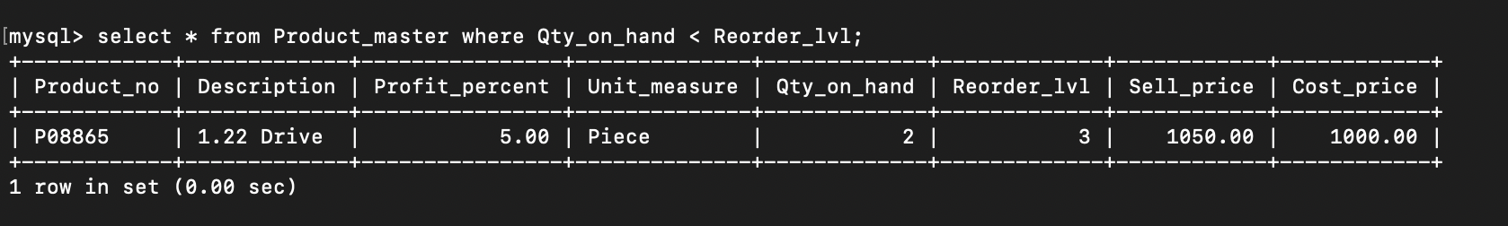

7)Count no. of products whose qty_on_hand is less than reorder level.

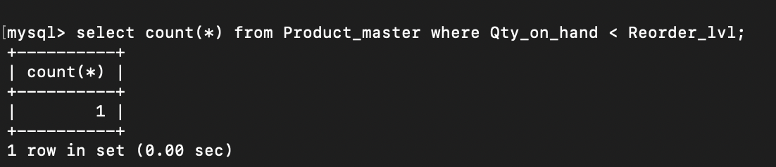

**Having and Group By:-**

1) Print the description and  total qty sold for each product.

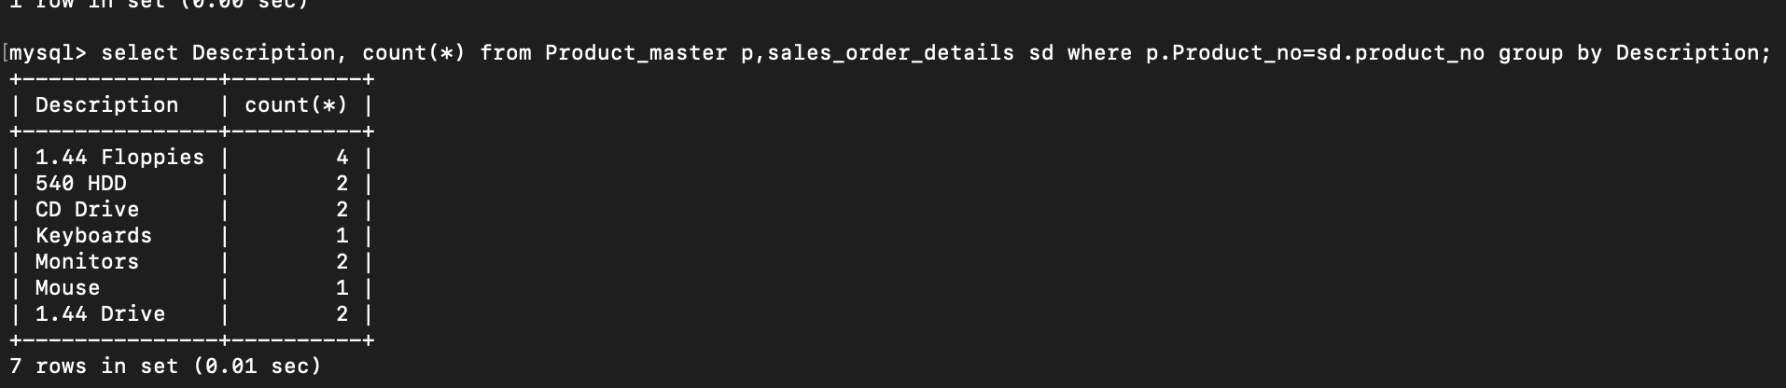

2) Find the value of each product sold.

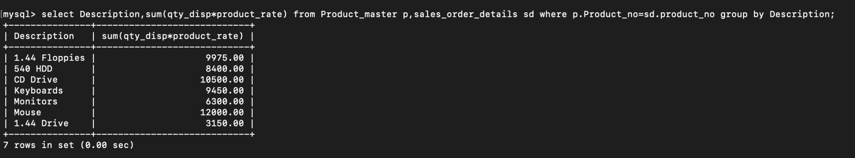

**Conclusion:-** LO mapped LO2,LO4.